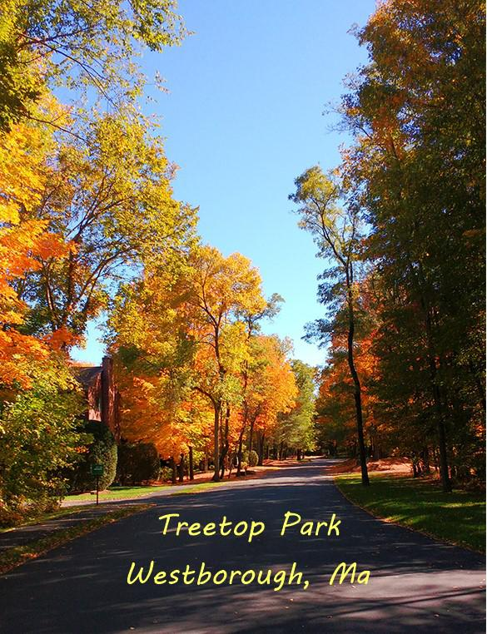
Welcome to Treetop Park

We are small diverse community
in Westborough, Massachusetts.

We take pride in our natural beauty and charm.
Webite: www.treetopparkwestborough.com email address: treetoppark1@gmail.com Reliable PropertyManagement:
Brad@relprop.net

Updated January 2025

Treetop Park was built in 1984 and consists of 60 individual units in 15 buildings.
- The buildings are made up of 32 Manor units (2 bedrooms, 1 and 1/2 bathroom, and 1 car garage) and 28 Star units (2 bedrooms, 2 and 1/2 bathrooms and 2 car garage).

- Governance: The unit owners elect a Board of Trustees. Day to day management of Treetop Park is carried out by the management company, Reliable Property Management, with all final decisions made by the elected board.
- Annual Meeting: An Open Annual Meeting is held once a year (usually in December or January). The Budget for the year is presented. Trustees are elected from the owners to serve on the Board. Old and new business is discussed. This is an extremely important meeting for all unit owners to attend. A quorum (50% by ownership) of unit owners is required for the election of the Board of Trustees.
- Board of Trustees Meetings: The Board meets monthly to discuss current issues effecting TTP and to make the decisions needed to run the community. After a closed executive session, there may be an open meeting where all unit owners are welcome to hear and express community concerns. The times and locations of all meeting are posted in a timely fashion.
- Condo Fees: Fees are determined by the board after careful consideration of the budget and financial requirements of maintaining the community. These funds are used to finance day to day maintenance (landscaping, snow removal and general upkeep) and to establish and build a reserve fund to finance larger infrastructure requirements needed in the future (roofs, roads, painting, decks etc.). On rare occasions additional assessments may be made, but the Board tries to avoid this if possible. Condo fees are due the 1st of the month and will incur a late fee if not received by the management company by the 15th of the month. Fees may be paid online at the Buildium web page: https://relpm.managebuilding.com/Resident/public/home
- Rules and Regulations: All governance of the Association is detailed in the Master Deed recorded at the Worcester Registry of Deeds. From time to time this document is updated. This booklet provides a summary of the current Rules and Regulations and provides a useful guide for unit owners for living at TTP.
General Information
Board Meetings:
Usually on the 4th Tuesday or Thursday of the month.
Open Session for Community: 7:15 pm by request.
Contact Reliable Property Management via email (treetoppark1@gmail.com)
if there are agenda items you would like discussed.

Safety Issues:
- For those who wait in vehicles with children at the bus stop at the entrance of TTP, please have your vehicle parked at least one car-length from the entrance so that incoming and outgoing cars can safely enter and exit.

- The speed limit on the TTP property is 15 MPH

- All resident-owned vehicles are to be parked in your respective driveways—not on the roadways. No overnight parking is permitted on any roadway within the complex.

- Dyer Duct and Chimney Cleaning are required every 3 years.

- All unmet safety requirements are subject to immediate fines.

Trash / Recycling Pickup:
The association provides a vendor for Trash and Recycling. The vendor provides and owns the 64 gallon bins. Each Unit is provided with 2 bins. Bins are to be stored in garages except for pickup times.
Trash pickup is every Wednesday.
Mixed Stream Recycling is every OTHER Wednesday.
The schedule is posted on the TTP website. There are a few alternate days due to Holidays throughout the year.
Bins must be put to the curb the night before, or by 6 am the day of pickup, free from obstructions, and readily visible to the truck driver.
Please face the front of the bin toward the street, with all items inside the bin, when putting out for pickup. The front of the bin is where the lid opens, the wheels are in the back.
The vendor provides guidance on what to recycle.

Fall / Winter Reminders:
Outdoor water spigots must be turned off - from the inside - for the winter season.

- Under-deck areas must be kept free of clutter and debris. Stored items must be secured safely for the winter season.

- Please leave outside lights on during snowstorms and park in garages to facilitate plowing.

- Holiday decorations (wreaths, holiday lights, etc.) can remain up during the month of the holiday.

Spring/Summer Reminders:
- Outdoor water spigots can, once again, be turned on for seasonal use.

- Please do not park on any grassy areas within the complex. This is a fined offense.
.
- No open fires (fire pits, Tiki torches) are permitted anywhere on the Treetop Park property, as this is a fire hazard. Please refer to the Westborough Fire Department regulations.

Long-term Maintenance Reminders for the Individual Units*:

Certain infrastructure items inside the Individual Units are critical to the maintenance and safety of the entire Treetop Property. Since these items are inside the Individual Unit, the Unit Owner is responsible for their maintenance.
Please note: Each Unit is different, and if a Unit Owner feels it is necessary, they are encouraged to perform extra maintenance and/or replacement in addition the requirements listed below.

Pressure valves were installed in individual units as part of the water system upgrade in 2016. These valves have an expected life of 10 years. Therefore, Unit Owners should plan to have them replaced in 2026.
Fireplaces are also the responsibility of the Unit Owner. Inspection and Proof of Maintenance is required every three years per the following schedule:
2026 2029 2032 2035 2038 etc.
Reliable Property Management will notify Unit Owners when these are due and how proof of compliance is recorded.

Dryer Ducts are also the responsibility of the Unit Owner. Proof of cleaning and maintenance is required every three years per the following schedule:
2025 2028 2031 2034 2037 etc.
Reliable Property Management will notify Unit Owners when these are due and how proof of compliance is recorded.

Long-term Maintenance of Common Elements** is the responsibility of the Treetop Park Condominium Association:

Painting and maintaining the unit exteriors, roofs, decks, trees, roads, etc. are items handled by the Association. The Management Company and the Board of Trustees work together to plan for long-term maintenance of the Common Elements.
Part of the monthly condo fee goes into a reserve account to finance these projects. For example: Roofs are replaced approximately every 20 years, decks every 10 to 15 years. These long-term plans are reviewed and updated as needed.

Please note: Due to Town of Westborough requirements, the four individual unit water meters in certain buildings are located in one of the units. That Owner may be called upon to provide access to the other units’ meters in cases of emergency or necessary repairs. All unit owners should have a water shut off valve for their Individual Unit*. The unit with the water meters must not deprive the other three units of water if their unit requires repairs. It is the responsibility of unit owners to take responsibility for any maintenance or repair within their unit.

Individual Unit*: Exclusive use by the Unit Owner, generally thought of as being from “studs in”, although the Unit Owner has an easement of the exterior in the immediate area around the unit (deck, driveway, etc.)

Common Elements**: Used and governed in common by the Treetop Park
Condominium Association* (building, exterior, roads, land, etc.)

EXTERIOR IMPROVEMENTS & REPLACEMENTS

Replacement of windows, garage doors, front entrance doors, and similar exterior improvements of any kind to individual units, are the responsibility of the Unit Owner and must be approved, in advance, by the Board of Trustees. The Board of Trustees reserves the right to determine appropriate vendors and specifications for these items to maintain the character and value of the Treetop Park property.

If any exterior changes are made without prior approval, Unit Owners will run the risk of fines and mandatory removal of items not in compliance. Removal costs and corrective compliant replacement will be at the Unit Owner's expense.

All requests must be initiated by Unit Owners and directed to Brad Page at Reliable Property Management, via email (brad@relprop.net) or by letter, with a description of the desired improvement and/or the specific item to be replaced, including detailed specs (photo, web link, catalog etc). The Board will make every effort to provide timely responses.

Below are guidelines for approved replacement items:
This information is also available on the website: www.treetopparkwestborough.com
These guidelines do not constitute automatic approval.

• Windows & Sliding Doors – Must be the same style and frame color as the original items.
Approved Vendors:
Pella Windows & Doors – Impervia (sliding door, however, has not been favorable to some, due to screen being on the inside of the door vs. the outside)
Andersen Windows & Doors,
Snead Brothers (Harvey Windows)
Note: If vendors other than the above are desired, please be informed that mullions (metal frame enclosures for the glass--perimeter and center) cannot exceed ½” in total width variance and must be in compliance with required shape. Board approval must be obtained prior to purchase.

• Garage Doors – Flat-paneled, and must be painted to match the Unit following installation (at Unit Owner’s expense). Contact Brad Page (brad@relprop.net) for specific brand and paint color.
Approved Contractors:
Rich Adams – Adams Door Service & Sons – 508 243-6444 (will paint doors)
John Small – J.W. Small Garage Door Installation – 508 789-1410 (does not paint doors)
Jolicoeur Overhead Doors 1-800-649-4522

• Entry and Storm Doors (main entrance door) – Plain white frame with full-view (steel, fiberglass, etc., with or without built-in blinds/shade).
These doors are generally special order items.
Approved Vendors:
Lowe’s, Koopman Lumber & Hardware, Home Depot

Useful Information:
EMERGENCY INFORMATION
Call 911 for Fire, Police or Ambulance (medical emergency only).

Reliable Property Management* | 508-435-1010 *
100 Granger Boulevard, Unit 103, Marlborough MA, 01752 | Brad@relprop.net
P.O. Box 78, Marlborough MA, 01752 | Mailing, billing address
Town of Westborough Departments
Fire Department (Non-Emergency) | 508-389-2300
Police Department (Non-Emergency) | 508-366-3060
Superintendent of Schools | 508-836-7700
Town clerk | 508-366-3020
Tax Collector | 508-366-3025
Town of Westborough Website
https://www.town.westborough.ma.us/

*Note: Please listen to the entire message when calling Reliable Property Management to obtain the emergency number if it is necessary during non-business hours.

Condominium Living:
There are some fundamental differences between condominiums and houses that a potential buyer should keep in mind when considering what type of residence to purchase for residential purposes:
- Ownership: Owning a house comes with the right to exclusive ownership of all the property you have purchased both inside and outside of the house. Essentially, this means that anyone who sets foot on any part of your property without your permission is considered trespassing. With condominiums, the owner only has exclusive right to all property within the walls of his own condominium unit. The owner only has shared ownership of "common area" outside of the condominium unit, such as the halls and courtyard, and he must share this space along with every other condominium unit owner in the complex
- Defects and Repairs: Homeowners are solely responsible for all upkeep and protection of their property, including purchasing insurance. Condominium owners are generally not solely responsible for the repairs and upkeep of the property. Instead, condo owners generally pay dues to the homeowners’ association that they are required to belong to, which is in charge of buying property hazard insurance for the entire condo complex and takes care of property maintenance in the common areas.
- Modification of the Property: Except for some local zoning ordinances, homeowners typically have the freedom to modify the exterior or interior or their property however they want to. In contrast, condo owners are generally restricted in the ways they can modify the exterior, and occasionally the interior, appearance of their residence by covenants, conditions, and restrictions (CC&Rs) that are usually set forth by the homeowners’ association they belong to.

From: http://www.legalmatch.com/law-library/article/buying-a-condominium-vs-buying-a-house.html

Treetop Park Map
Unit Numbers and
Building Numbers

Westborough Assessor's Map
Treetop Park property and nearest abutters

